State of Illinois
Illinois Department of Public Health
COVID‐19
Social Distancing
Social distancing actions are taken to restrict when and where people can gather to stop or slow the spread of coronavirus disease (COVID‐19) or other infectious diseases in communities. Social distancing actions include limiting large groups of people coming together, closing buildings or canceling events.

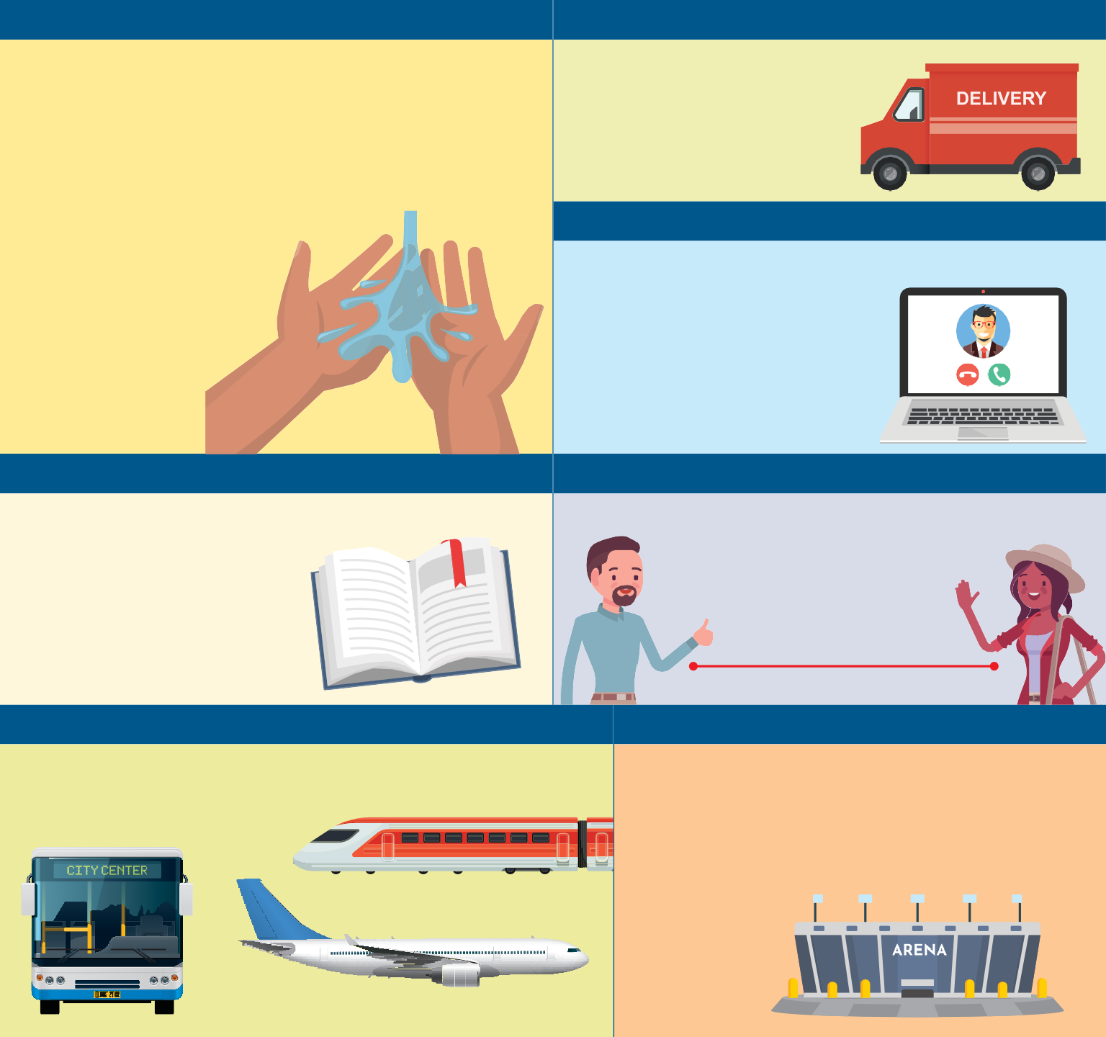
Protect yourself and your community Change your daily habits

Wash your hands often with soap and water for at least 20 seconds, especially after going to the bathroom, before eating, and after blowing your nose, coughing or sneezing.
If you don’t have soap or water, use an alcohol‐based hand sanitizer
with at least 60 percent alcohol. Avoid close contact with people who are sick
and stay home when you’re sick.
Avoid shopping at peak hours and take advantage of delivery
or pick‐up services with retailers.

Work with your employer
Cooperate with leadership to change company practices, set up flexible shift
plans, have employees telecommute, and cancel large
meetings or conferences.

Universities and colleges
Consider suspending on campus classes, implementing web‐based
learning and canceling large campus meetings and gatherings.

Keep at least six feet between you and others.
Avoid shaking hands as a social greeting.

6 feet

Public transit
Avoid public transit if possible and don’t travel to areas with active outbreaks.

Crowded places
Avoid crowded places. Events with 1,000 or more people have been canceled. Community events with 250 or more recommended be canceled or postponed. Major sports events are canceled.

Questions about COVID‐19? Call 1‐800‐889‐3931 or email dph.sick@illinois.gov Illinois Department of Public Health ‐ www.dph.illinois.gov
Printed by Authority of the State of Illinois • 3/13/20 IOCI 20‐643

